AWS Cloud project
This project builds a high-performance Content Management System (CMS) for Zonet Technology using AWS infrastructure to ensure scalability and reliability. Amazon EC2 hosts the CMS application, while Amazon RDS manages relational databases for storing content and metadata. Amazon S3 is used for storing media files, and Amazon CloudFront accelerates global content delivery. AWS Elastic Load Balancing distributes incoming traffic evenly across instances, ensuring high availability, optimal performance, and seamless user experience.

Steps:
- Create an EC2 instance
- Create and amazon RDP
- Create an S3 bucket
- Create and configure the cloud front
- Create and setup the ELB and monitor the ec2 instance.
- s3://nainprimarybackup/index.html
- https://nainprimarybackup.s3.ap-south-1.amazonaws.com/index.html

EC2 instance
- Go to EC2 instance, click Launch Instance.
- Type CMS_Linux_Server in name.
- Choose Amazon Linux(AWS).
- Choose Amazon Linux 2023 kernel-6.1 AMI (Free tier) in Amazon Machine Image(AMI).
- Choose t3.micro in Instance type.
- Choose Mani_LinuxAM in Key pair name.
- In Network settings tab Click Edit -> Choose default vpc in VPC and select default security group in common security group.
- Finally Click Launch instance button.
- Run and connect the instance. Here will not use to root use. So don’t run Command is Sudo su -.
- Check all the packages are up to date command.
sudo dnf update -y
- Install PHP command
sudo dnf install -y httpd wget php-fpm php-mysqli php-json php php-devel
- Install database server
sudo dnf install -y mariadb105-server
- Check the maria db version
dnf info mariadb105
- Start the apache server and enable to launch on boot.
sudo systemctl start httpd && sudo systemctl enable httpd
- Verify is apache is enabled
sudo systemctl is-enabled httpd
- Add your user(ec2-user) in the apache group
sudo usermod -a -G apache ec2-user
- Now logout and login back in again to refresh the group.
exit
groups
- Adjust your permissions for the web directory.
sudo chown -R ec2-user:apache /var/www
sudo chmod 2775 /var/www && find /var/www -type d -exec sudo chmod 2775 {} \;
find /var/www -type f -exec sudo chmod 0664 {} \;
- Test PHP installation by creating a PHP file.
echo "<?php phpinfo(); ?>" > /var/www/html/phpinfo.php
- After that go to browser copy and paste public ip in ec2 instance.
http://13.202.34.56//phpinfo.php
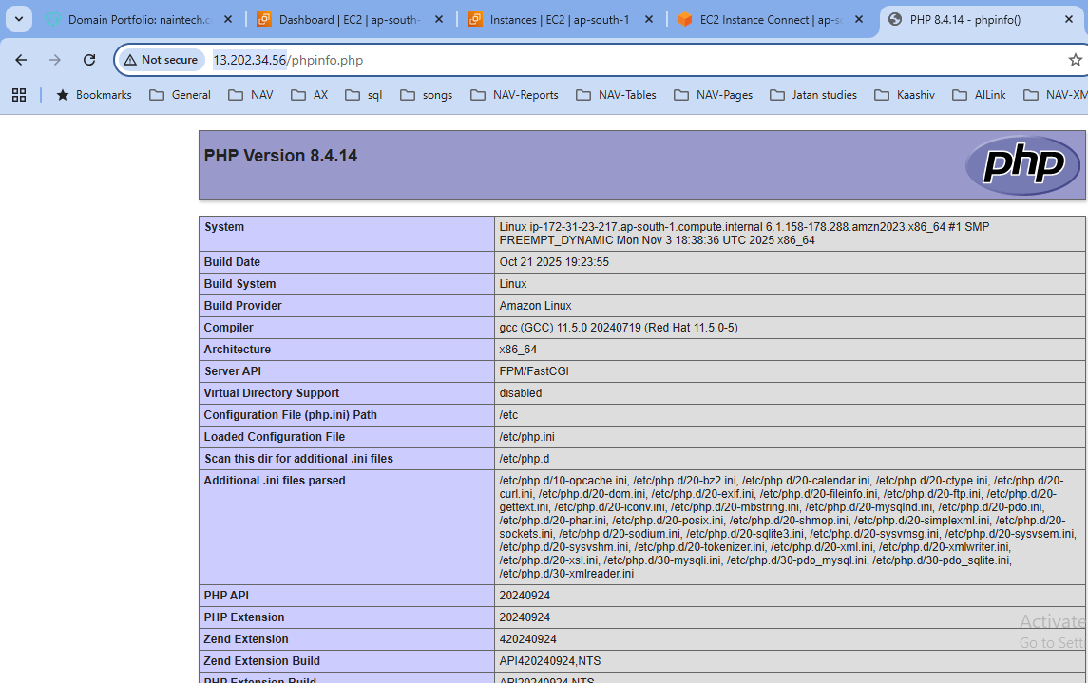
- Remove the file
rm /var/www/html/phpinfo.php
- Start MariaDB and secure for installation.
sudo systemctl start mariadb
sudo mysql_secure_installation
- Root password is Mani1991.
- Download the latest wordpress package and extract it.
wget https://wordpress.org/latest.tar.gz - download code
tar -xzf latest.tar.gz - Extract code
- Start both Apache and MariaDB if not already running
sudo systemctl start mariadb httpd
- Create a database for wordpress to access the mysql shell as root
mysql -u root -p
- Create a new database and user for wordpress
CREATE USER 'mani_user'@'localhost' IDENTIFIED BY 'Mani1991';

- Create the database name
CREATE DATABASE `office_db`;
- Grant full privileges for your database to the WordPress user(mani-user) that you created earlier
GRANT ALL PRIVILEGES ON `office_db`.* TO "mani_user"@"localhost";
- Flush the database privileges to pick up all of your changes
FLUSH PRIVILEGES;
- Exit the mysql client.
exit
- Configure wordpress, Copy the WordPress sample configuration file and edit it with your database details and Update the database name, user, and password in the wp-config.php file.
cp wordpress/wp-config-sample.php wordpress/wp-config.php
nano wordpress/wp-config.php

define('DB_NAME', 'office_db');
define(‘DB_USER’, ‘mani_user'); or root_user
define(‘DB_PASSWORD’, ‘Mani1991’);
- Deploy wordpress Copy the WordPress files to your web directory
cp -r wordpress/* /var/www/html/
- If you wish to install WordPress in a subdirectory, such as /blog, create the directory and copy the files
mkdir /var/www/html/blog
cp -r wordpress/* /var/www/html/blog/
- Configuration apache, Before finalizing the installation, you may need to adjust the Apache configuration.
sudo nano /etc/httpd/conf/httpd.conf
- Find the section that starts with <Directory “/var/www/html”>.
Change the AllowOverride None line in the above section to read AllowOverride All.
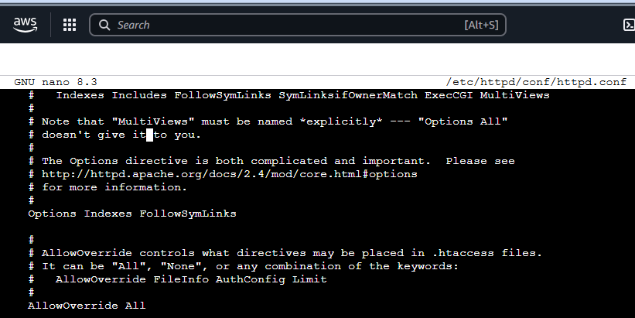
- Finalize the installation, Restart Apache to apply the changes
sudo systemctl restart httpd
- Now go to the browser copy the public IPv4 address in ec2 instance an paste it in the browser url.
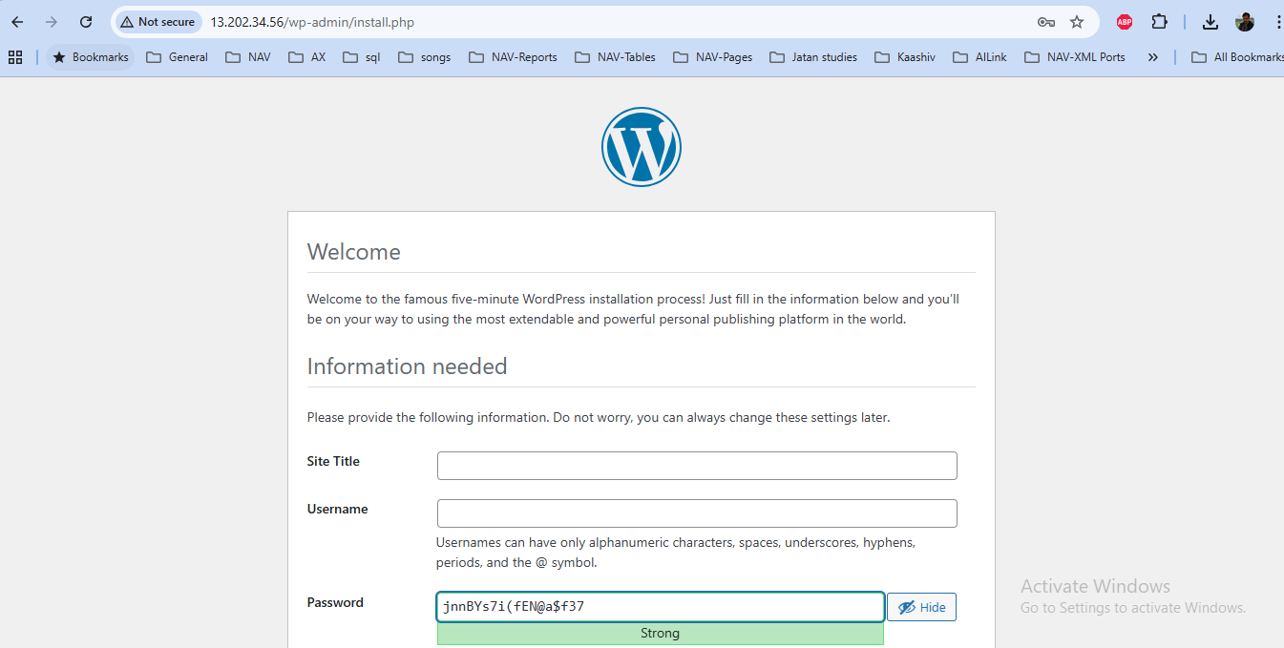

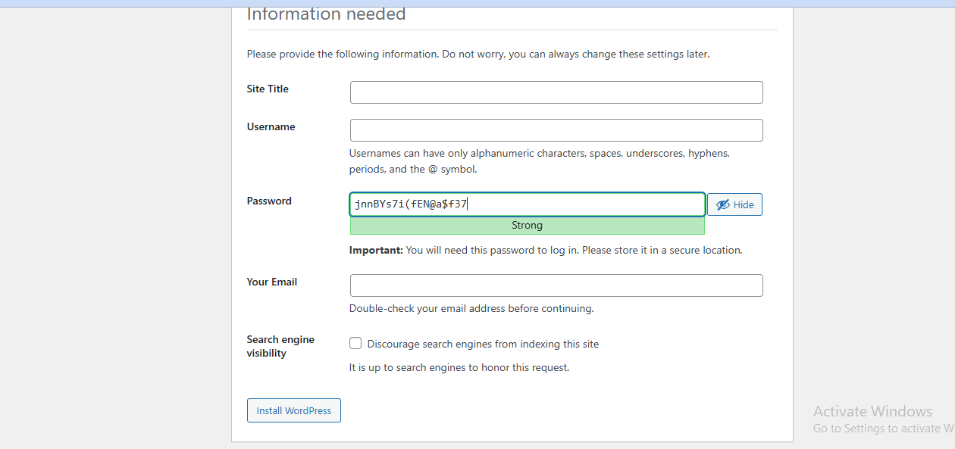

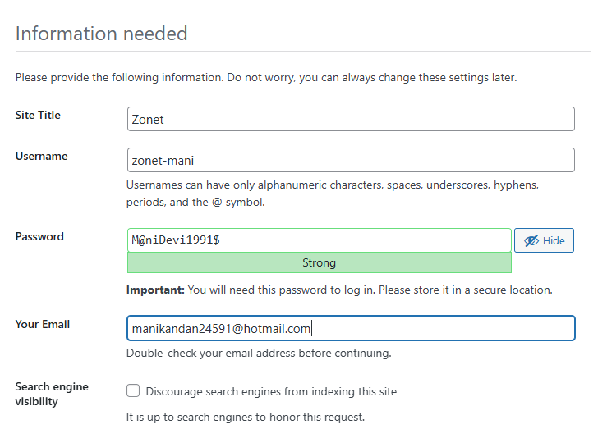
- Fill the details and click install wordpress and then login user name and password
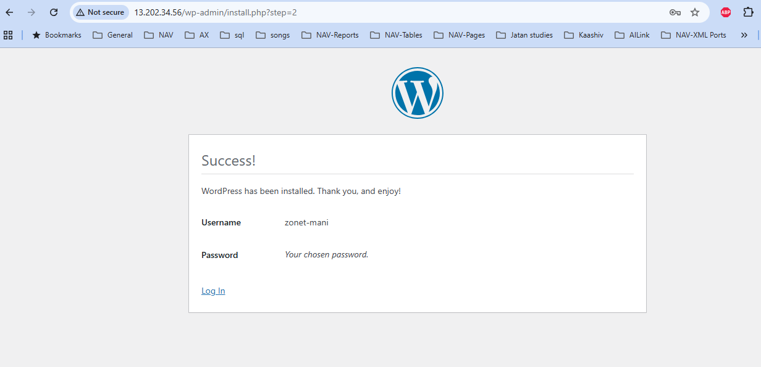
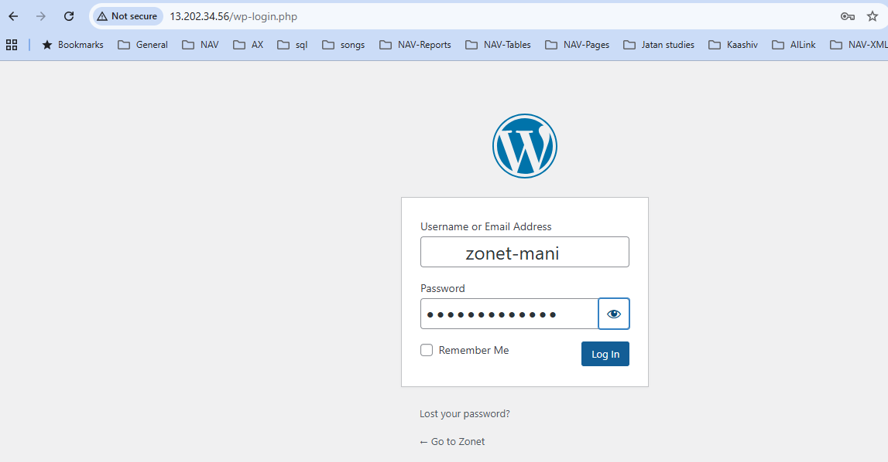
- Now enter the username and password, after click login.
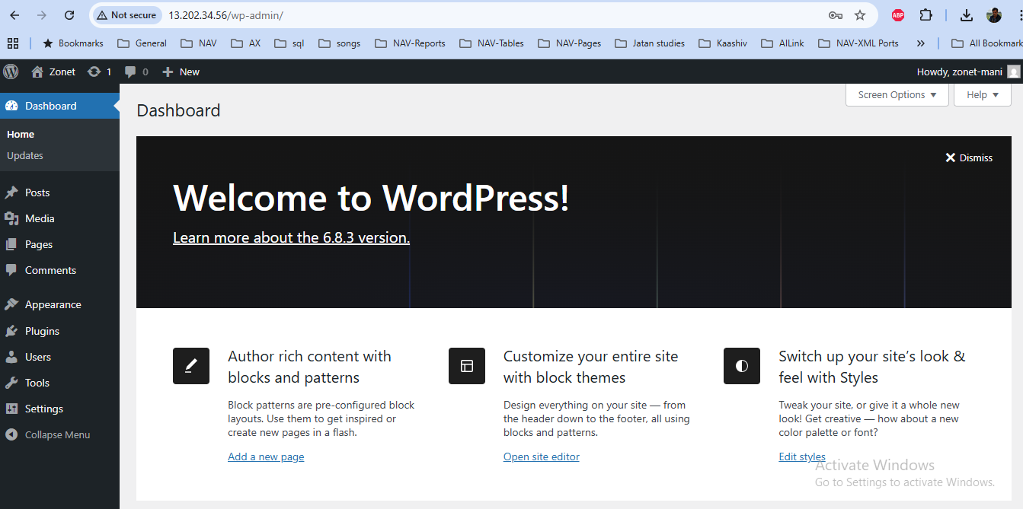
- Now Put the public ip4 address the website has been launched.
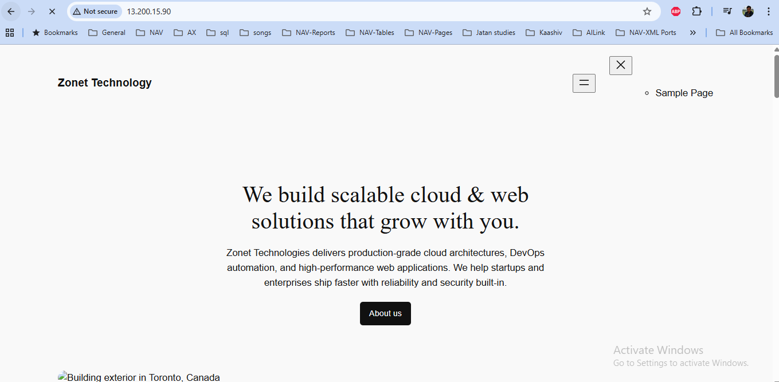

Load balancers
- Type Load Balancers in search bar, select Load balancers for EC2 instance.
- Click Create Load Balancer button.
- Choose Application Load Balancers and click Create button.
- Type zonet-balancer in Load Balancer name.
- Choose Internet-facing in Scheme.
- Choose IPv4 Load Balancer IP address type.
- Choose ap-south-1a, ap-south-1b, ap-south-1c in Availability zone.
- Choose Forward to target groups in Routing action.
- Click Create target group link .
- Type Zonet-Target in Target group name and Click Next.
- Choose your CMS_Linux_Server EC2 Instance , Click Include as pending below button. Click Next.
- Click Create Target Group Button.
- Now Choose zonet-balancer in Target Group.
- Click Create Load Balancer.
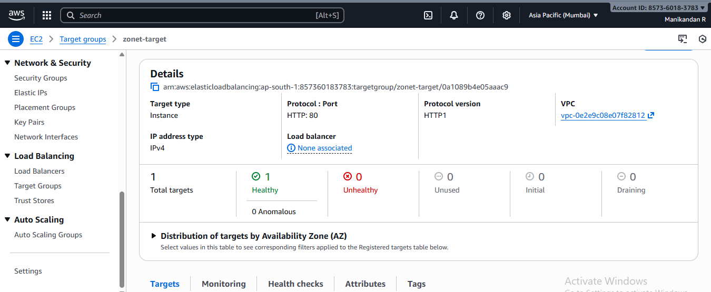
- Now Target group is Healthy is coming.
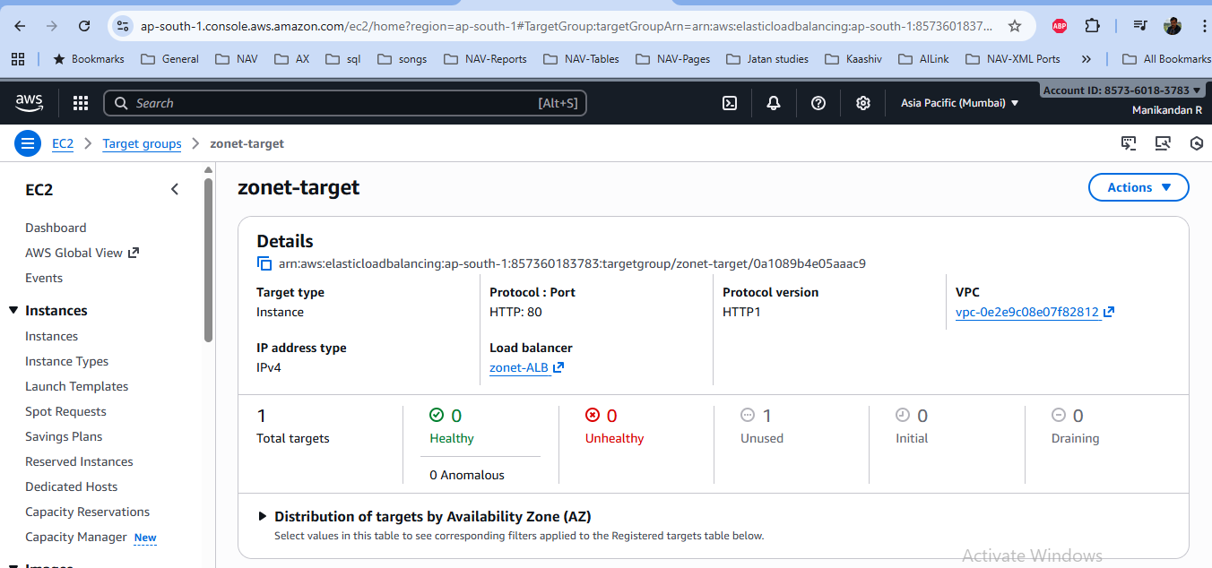
- After stop the CMS EC2 Instance. Now Target group is healthy changed to unused is coming. Now Click the monitoring menu in Load balancers and Target group. Now data visualization is also changed.
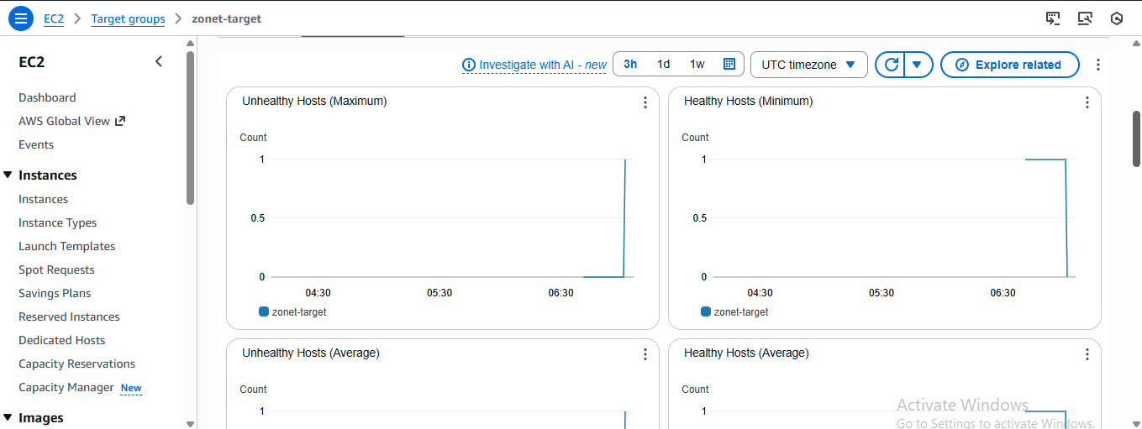

Reboot the instance after try steps
- After finished you will restart the instance and connect the instance. Now below the script only we can used
A newer release of "Amazon Linux" is available.
Version 2023.9.20251117:
Run "/usr/bin/dnf check-release-update" for full release and version update info
, #_
~\_ ####_ Amazon Linux 2023
~~ \_#####\
~~ \###|
~~ \#/ ___ https://aws.amazon.com/linux/amazon-linux-2023
~~ V~' '->
~~~ /
~~._. _/
_/ _/
_/m/'
Last login: Sat Nov 22 07:15:22 2025 from 13.233.177.5
[ec2-user@ip-172-31-23-217 ~]$ sudo su -
Last login: Sat Nov 22 07:15:57 UTC 2025 on pts/1
[root@ip-172-31-23-217 ~]# sudo dnf install -y httpd wget php-fpm php-mysqli php-json php php-devel
Last metadata expiration check: 0:04:19 ago on Thu Dec 4 11:36:07 2025.
Package httpd-2.4.65-1.amzn2023.0.2.x86_64 is already installed.
Package wget-1.21.3-1.amzn2023.0.4.x86_64 is already installed.
Package php8.4-fpm-8.4.14-1.amzn2023.0.1.x86_64 is already installed.
Package php8.4-mysqlnd-8.4.14-1.amzn2023.0.1.x86_64 is already installed.
Package php8.4-common-8.4.14-1.amzn2023.0.1.x86_64 is already installed.
Package php8.4-8.4.14-1.amzn2023.0.1.x86_64 is already installed.
Package php8.4-devel-8.4.14-1.amzn2023.0.1.x86_64 is already installed.
Dependencies resolved.
Nothing to do.
Complete!
[root@ip-172-31-23-217 ~]# dnf info mariadb105
Last metadata expiration check: 0:04:49 ago on Thu Dec 4 11:36:07 2025.
Installed Packages
Name : mariadb105
Epoch : 3
Version : 10.5.29
Release : 1.amzn2023.0.1
Architecture : x86_64
Size : 18 M
Source : mariadb105-10.5.29-1.amzn2023.0.1.src.rpm
Repository : @System
From repo : amazonlinux
Summary : A very fast and robust SQL database server
URL : http://mariadb.org
License : GPLv2 and LGPLv2
Description : MariaDB is a community developed fork from MySQL - a multi-user, multi-threaded
: SQL database server. It is a client/server implementation consisting of
: a server daemon (mariadbd) and many different client programs and libraries.
: The base package contains the standard MariaDB/MySQL client programs and
: utilities.

[root@ip-172-31-23-217 ~]# sudo systemctl start httpd && sudo systemctl enable httpd
[root@ip-172-31-23-217 ~]# sudo systemctl is-enabled httpd
enabled
[root@ip-172-31-23-217 ~]# sudo systemctl start mariadb httpd
[root@ip-172-31-23-217 ~]# sudo systemctl restart httpd

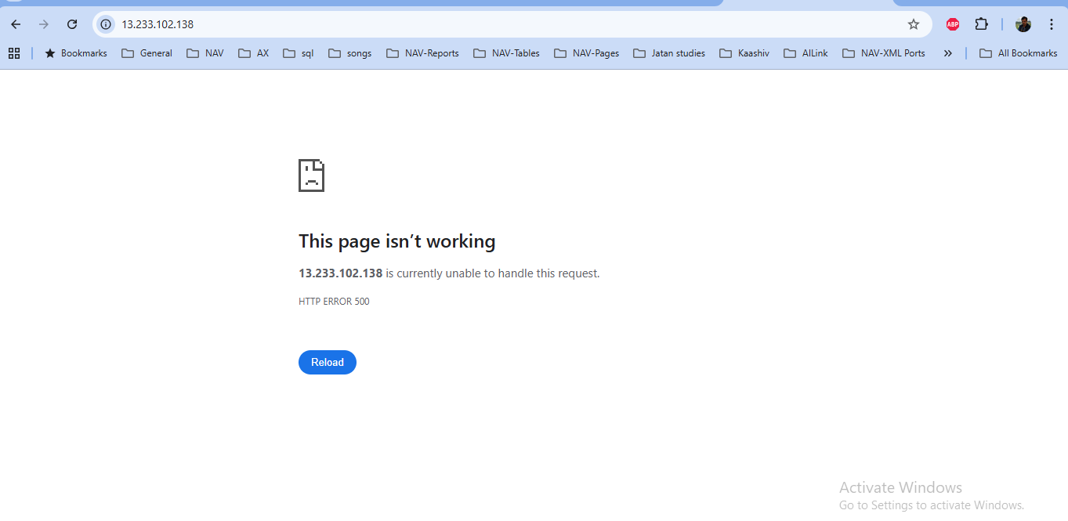

[ec2-user@ip-172-31-1-85 ~]$ groups
ec2-user adm wheel apache systemd-journal
[ec2-user@ip-172-31-1-85 ~]$ sudo chown -R ec2-user:apache /var/www
sudo chmod 2775 /var/www && find /var/www -type d -exec sudo chmod 2775 {} \;
find /var/www -type f -exec sudo chmod 0664 {} \;
[ec2-user@ip-172-31-1-85 ~]$ echo "<?php phpinfo(); ?>" > /var/www/html/phpinfo.php
[ec2-user@ip-172-31-1-85 ~]$ rm /var/www/html/phpinfo.php
[ec2-user@ip-172-31-1-85 ~]$ sudo systemctl start mariadb
sudo mysql_secure_installation

NOTE: RUNNING ALL PARTS OF THIS SCRIPT IS RECOMMENDED FOR ALL MariaDB
SERVERS IN PRODUCTION USE! PLEASE READ EACH STEP CAREFULLY!

In order to log into MariaDB to secure it, we'll need the current
password for the root user. If you've just installed MariaDB, and
haven't set the root password yet, you should just press enter here.

Enter current password for root (enter for none):
OK, successfully used password, moving on...

Setting the root password or using the unix_socket ensures that nobody
can log into the MariaDB root user without the proper authorisation.

You already have your root account protected, so you can safely answer 'n'.

Switch to unix_socket authentication [Y/n] Y
Enabled successfully!
Reloading privilege tables..
... Success!

You already have your root account protected, so you can safely answer 'n'.

Change the root password? [Y/n] Y
New password:
Re-enter new password:
Password updated successfully!
Reloading privilege tables..
... Success!

By default, a MariaDB installation has an anonymous user, allowing anyone
to log into MariaDB without having to have a user account created for
them. This is intended only for testing, and to make the installation
go a bit smoother. You should remove them before moving into a
production environment.

Remove anonymous users? [Y/n] Y
... Success!

Normally, root should only be allowed to connect from 'localhost'. This
ensures that someone cannot guess at the root password from the network.

Disallow root login remotely? [Y/n] Y
... Success!

By default, MariaDB comes with a database named 'test' that anyone can
access. This is also intended only for testing, and should be removed
before moving into a production environment.

Remove test database and access to it? [Y/n] Y
- Dropping test database...
... Success!
- Removing privileges on test database...
... Success!

Reloading the privilege tables will ensure that all changes made so far
will take effect immediately.

Reload privilege tables now? [Y/n] Y
... Success!

Cleaning up...

All done! If you've completed all of the above steps, your MariaDB
installation should now be secure.

Thanks for using MariaDB!
[ec2-user@ip-172-31-1-85 ~]$ wget https://wordpress.org/latest.tar.gz
--2025-12-11 05:32:46-- https://wordpress.org/latest.tar.gz
Resolving wordpress.org (wordpress.org)... 198.143.164.252, 2607:f978:5:8002::c68f:a4fc
Connecting to wordpress.org (wordpress.org)|198.143.164.252|:443... connected.
HTTP request sent, awaiting response... 200 OK
Length: 27058021 (26M) [application/octet-stream]
Saving to: ‘latest.tar.gz’

latest.tar.gz 100%[=======================================================================>] 25.80M 8.21MB/s in 3.7s

2025-12-11 05:32:50 (7.03 MB/s) - ‘latest.tar.gz’ saved [27058021/27058021]

[ec2-user@ip-172-31-1-85 ~]$ ls
latest.tar.gz
[ec2-user@ip-172-31-1-85 ~]$ tar -xzf latest.tar.gz
[ec2-user@ip-172-31-1-85 ~]$ sudo systemctl start mariadb httpd
[ec2-user@ip-172-31-1-85 ~]$ mysql -u root -p
Enter password:
Welcome to the MariaDB monitor. Commands end with ; or \g.
Your MariaDB connection id is 13
Server version: 10.5.29-MariaDB MariaDB Server

Copyright (c) 2000, 2018, Oracle, MariaDB Corporation Ab and others.

Type 'help;' or '\h' for help. Type '\c' to clear the current input statement.

MariaDB [(none)]> CREATE USER 'mani-user'@'localhost' IDENTIFIED BY 'Mani1991';
Query OK, 0 rows affected (0.002 sec)

MariaDB [(none)]> CREATE DATABASE `office-db`;
Query OK, 1 row affected (0.000 sec)

MariaDB [(none)]> GRANT ALL PRIVILEGES ON `office-db`.* TO "mani-user"@"localhost";
Query OK, 0 rows affected (0.001 sec)

MariaDB [(none)]> FLUSH PRIVILEGES;
Query OK, 0 rows affected (0.000 sec)

MariaDB [(none)]> exit
Bye
[ec2-user@ip-172-31-1-85 ~]$ cp wordpress/wp-config-sample.php wordpress/wp-config.php
nano wordpress/wp-config.php
[ec2-user@ip-172-31-1-85 ~]$ cp -r wordpress/* /var/www/html/
[ec2-user@ip-172-31-1-85 ~]$ mkdir /var/www/html/blog
cp -r wordpress/* /var/www/html/blog/
[ec2-user@ip-172-31-1-85 ~]$ sudo nano /etc/httpd/conf/httpd.conf
[ec2-user@ip-172-31-1-85 ~]$ sudo systemctl restart httpd

MariaDB [(none)]> CREATE USER 'mani-user'@'localhost' IDENTIFIED BY 'Mani1991';
Query OK, 0 rows affected (0.002 sec)

MariaDB [(none)]> CREATE DATABASE `office-db`;
Query OK, 1 row affected (0.000 sec)

MariaDB [(none)]> GRANT ALL PRIVILEGES ON `office-db`.* TO "mani-user"@"localhost";
Query OK, 0 rows affected (0.001 sec)

MariaDB [(none)]> FLUSH PRIVILEGES;
Query OK, 0 rows affected (0.000 sec)

MariaDB [(none)]> exit

